Project Overview
This project focuses on developing a deep learning model for automated oil spill detection using satellite imagery. The system employs semantic segmentation techniques to identify and delineate oil spills in ocean environments, providing crucial capabilities for environmental monitoring, disaster response, and maritime safety.
Key Objectives:
- Develop accurate segmentation models for oil spill identification
- Process and analyze satellite imagery data
- Create a reliable environmental monitoring tool
- Enable rapid response to oil spill incidents
- Support environmental protection agencies and maritime authorities
Dataset Architecture
The project utilizes a comprehensive Oil Spill Dataset structured with meticulous organization to facilitate effective model training and evaluation.
Dataset Organization Structure:
The dataset follows a standardized segmentation dataset format with three distinct splits for training, validation, and testing purposes. Each split contains corresponding image-mask pairs that enable supervised learning approaches.
Data Distribution:
- Training Set: Contains over 1000 annotated oil spill images with corresponding binary masks for model training
- Validation Set: Comprehensive validation split used for hyperparameter tuning and model selection during training
- Test Set: 100+ independent images reserved for final model evaluation and performance assessment
- Mask Format: Binary segmentation masks in PNG format providing precise oil spill boundaries
Data Loading and Preprocessing Pipeline
Data Acquisition and Storage:
The project employs cloud-based storage solutions with Google Drive integration for efficient data management. This approach ensures data accessibility while maintaining version control and backup capabilities.
Dataset Extraction Process:
Automated extraction procedures handle compressed dataset archives, verifying file integrity and proper directory structure creation. The extraction process includes error handling for corrupted files and missing data scenarios.
Directory Structure Validation:
Comprehensive file system verification ensures all dataset components are properly organized and accessible. The validation process confirms the presence of corresponding image-mask pairs across all dataset splits and verifies file naming conventions.
Data Exploration and Analysis Framework
Statistical Analysis Components:
The project implements thorough statistical profiling of the dataset including image resolution analysis, color distribution examination, and oil spill morphological characteristics. This analysis informs preprocessing decisions and model architecture choices.
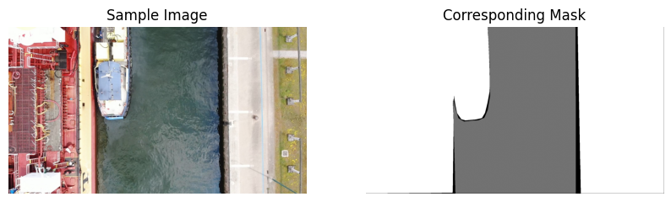

Dataset Quality Assessment:
Comprehensive quality checks evaluate image clarity, mask accuracy, annotation consistency, and dataset balance. These assessments ensure the training data meets the requirements for robust model development.
Visualization Infrastructure:
Advanced visualization techniques provide insights into data distribution, feature patterns, and potential challenges. The visualization framework supports both qualitative assessment and quantitative analysis of dataset characteristics.
Data Preprocessing and Augmentation
Image Preprocessing Pipeline:
The preprocessing workflow includes normalization procedures, color space transformations, and resolution standardization. These steps ensure consistent input data formatting while preserving critical feature information.
Data Augmentation Strategies:
Comprehensive augmentation techniques address dataset limitations and improve model generalization. The augmentation pipeline includes geometric transformations, color variations, and noise injection to simulate real-world conditions.
Mask Processing and Validation:
Binary mask processing ensures accurate label representation with proper boundary definitions. Validation procedures confirm mask-image alignment and annotation consistency across the entire dataset.
Model Architecture Design
Deep Learning Framework Selection:
The project employs state-of-the-art semantic segmentation architectures optimized for satellite imagery analysis. The model selection process considers computational efficiency, accuracy requirements, and deployment constraints.
Feature Extraction Components:
Advanced convolutional neural networks extract multi-scale features from input images, capturing both local textures and global contextual information essential for accurate oil spill detection.
Segmentation Head Design:
Specialized segmentation heads process extracted features to generate precise pixel-wise classifications. The design incorporates boundary refinement techniques and multi-resolution feature fusion.
Training Methodology

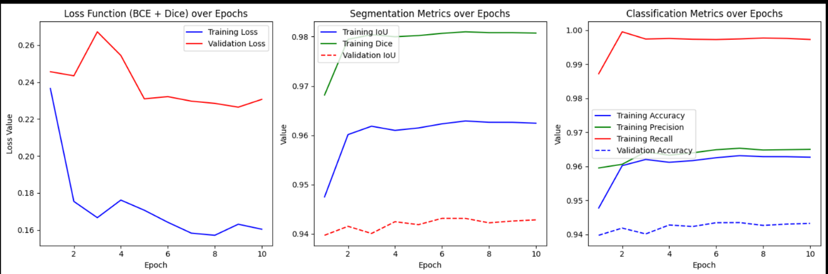
Optimization Strategy:
The training process employs advanced optimization algorithms with adaptive learning rates and gradient clipping. Loss function selection addresses class imbalance and boundary accuracy challenges.
Validation and Monitoring:
Comprehensive validation protocols monitor training progress, detect overfitting, and guide hyperparameter adjustments. Performance metrics track both segmentation accuracy and computational efficiency.
Regularization Techniques:
Multiple regularization methods prevent overfitting and improve model generalization. These include spatial dropout, weight decay, and data augmentation during training.
Evaluation Framework
Performance Metrics:
The evaluation system employs multiple metrics including intersection over union, pixel accuracy, F1 scores, and boundary matching metrics to provide comprehensive performance assessment.
Comparative Analysis:
Benchmark comparisons against baseline methods and existing approaches validate the proposed solution's effectiveness and identify areas for improvement.
Robustness Testing:
Extensive testing evaluates model performance across varying environmental conditions, image qualities, and oil spill characteristics to ensure real-world applicability.
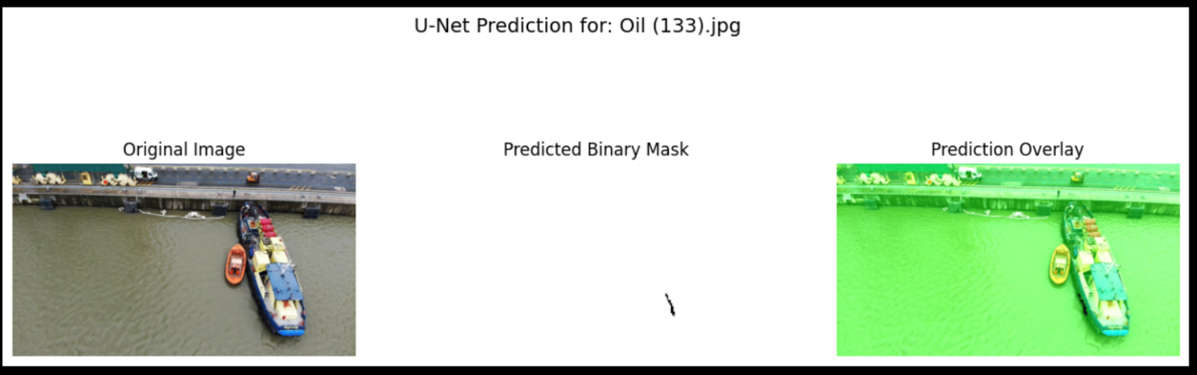

Results and Performance Analysis
Quantitative Results:
Detailed performance analysis provides insights into model accuracy, precision-recall characteristics, and computational requirements across different dataset conditions.
Qualitative Assessment:
Visual results demonstrate model performance on representative test cases, highlighting strengths in boundary detection, false positive reduction, and challenging scenario handling.
Error Analysis:
Comprehensive error analysis identifies common failure modes, challenging scenarios, and limitations to guide future improvements and deployment considerations.
Deployment Considerations
Integration Framework:
The deployment architecture supports integration with existing satellite data pipelines and environmental monitoring systems, ensuring practical applicability.
Performance Optimization:
Model optimization techniques balance accuracy requirements with computational constraints for efficient deployment in resource-limited environments.
Scalability and Maintenance:
The solution design accommodates scaling to larger geographical areas and incorporates mechanisms for continuous model improvement through feedback loops and data updates.
Future Enhancements
Technical Improvements:
Planned enhancements include multi-temporal analysis, integration with additional sensor data, and adaptive learning capabilities for evolving environmental conditions.
Feature Extensions:
Future development focuses on spill volume estimation, drift prediction, and source identification to provide comprehensive oil spill monitoring capabilities.
Integration Opportunities:
Potential integration with maritime traffic monitoring, weather data systems, and automated alert mechanisms to create a comprehensive environmental protection platform.
